TESTNG:

1. Non priority test cases will be picked first and the priority based testcases will be executed
2. To ignore a test case-----------🡪enabled = **false**
3. To give priority to test cases------------🡪priority = 1
4. Priority can be –ve also and also 0 as it is integers but in real time we don’t give these. We use +ve numbers only.
5. expectedExceptions = ArithmeticException.**class---- This is an ex**

@Test(expectedExceptions = ArithmeticException.**class**)

**public** **void** loginTest() {

**int** i=9/0;

}

@Test(expectedExceptions = {ArithmeticException.**class**,NullPointerException.**class**,Throwable.**class**})

**public** **void** loginTest() {

**int** i=9/0;

}

6.The test cases will be executed number of times mentioned

@Test(invocationCount = 10)

**public** **void** createUser() {

System.***out***.println("create user test....");

}

***Q. Can we use parameters in TestNG Annotations?***

*Yes, using parameters is a very common way to use annotations. Parameters can be used similarly to a method in Java. An example of using parameters along with the annotations :*

public class ParameterInTestNG {

@Parameters({ "suite-param" })

@Test

public void prameterTestOne(String param) {

System.out.println("Test one suite param is: " + param);

}

**Q.Are multiple parameters allowed in annotations?**

Yes, you can use multiple parameters in the annotations.

**Groups in TestNG:**

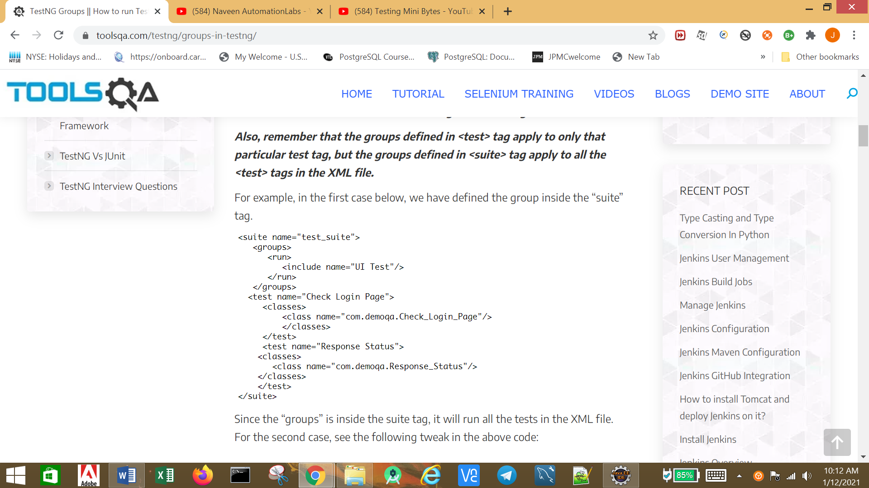

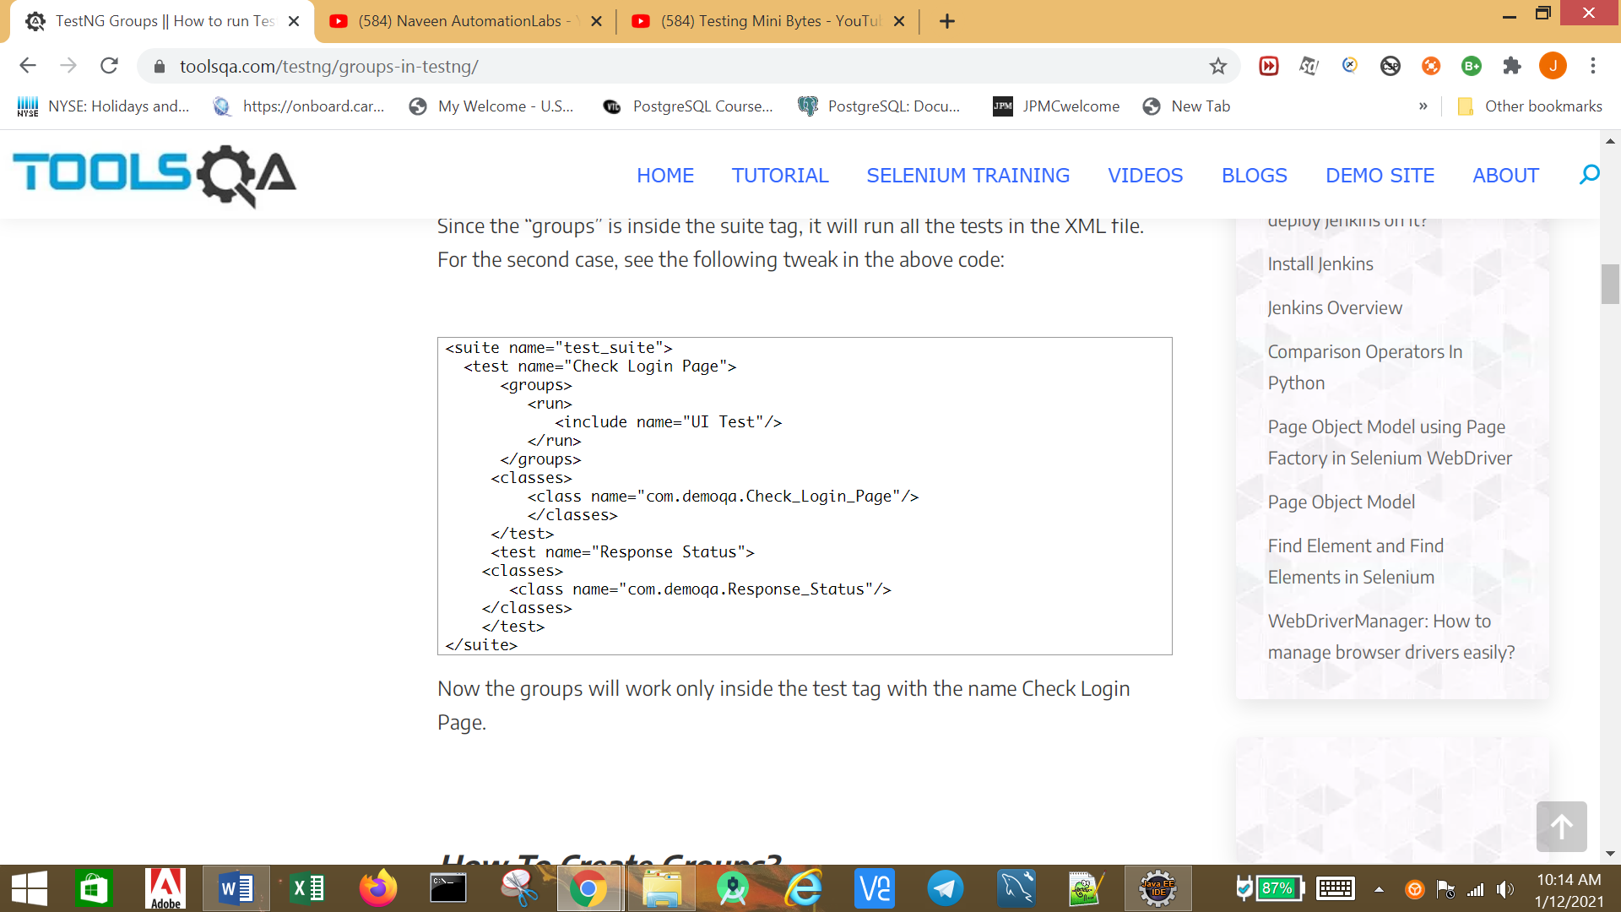

Groups inside groups:

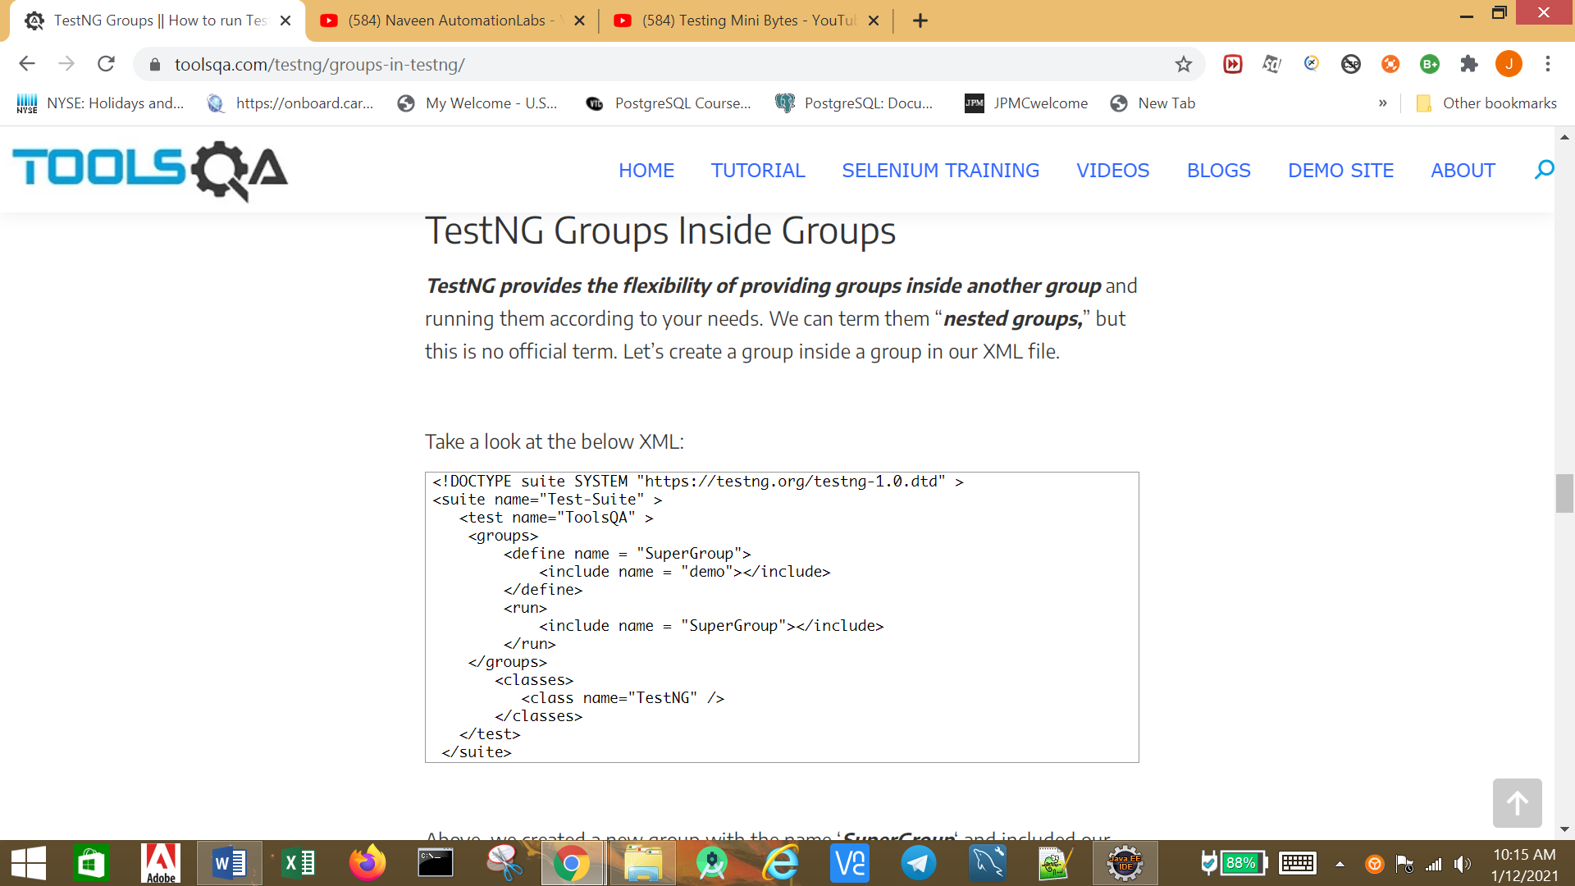

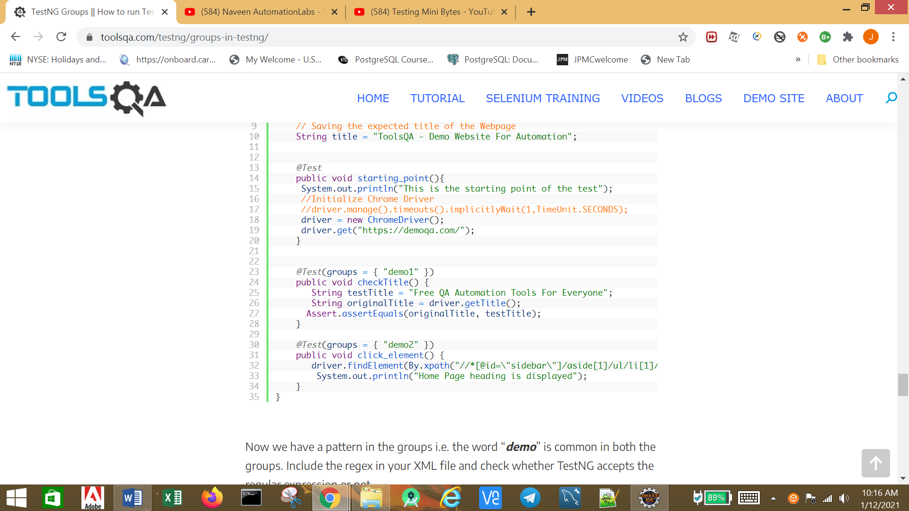

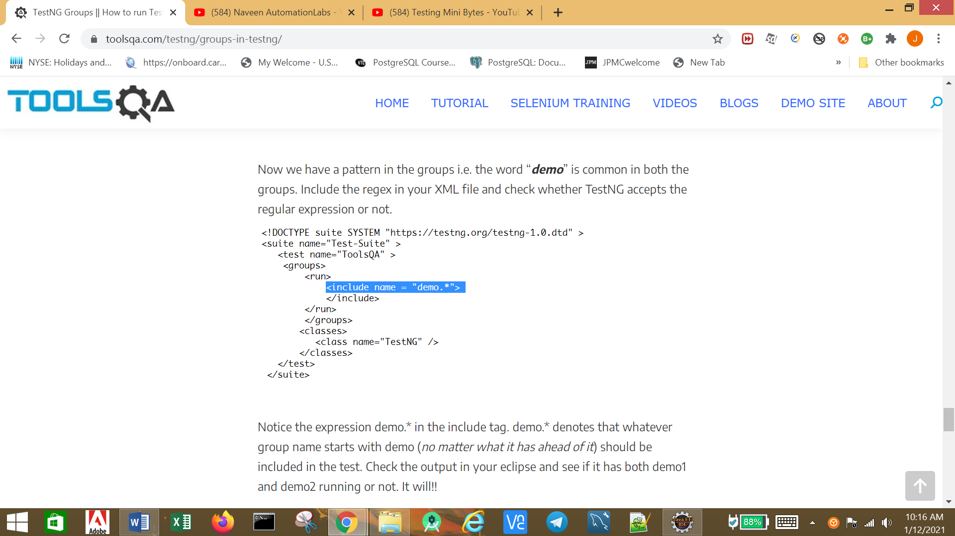

**TestNG – Dependent Tests**

***What Are TestNG Dependent Tests?***

* ***Single Dependent Test Methods***
* ***Multiple Dependent Test Methods***
* ***Inherited Dependent Test Methods***

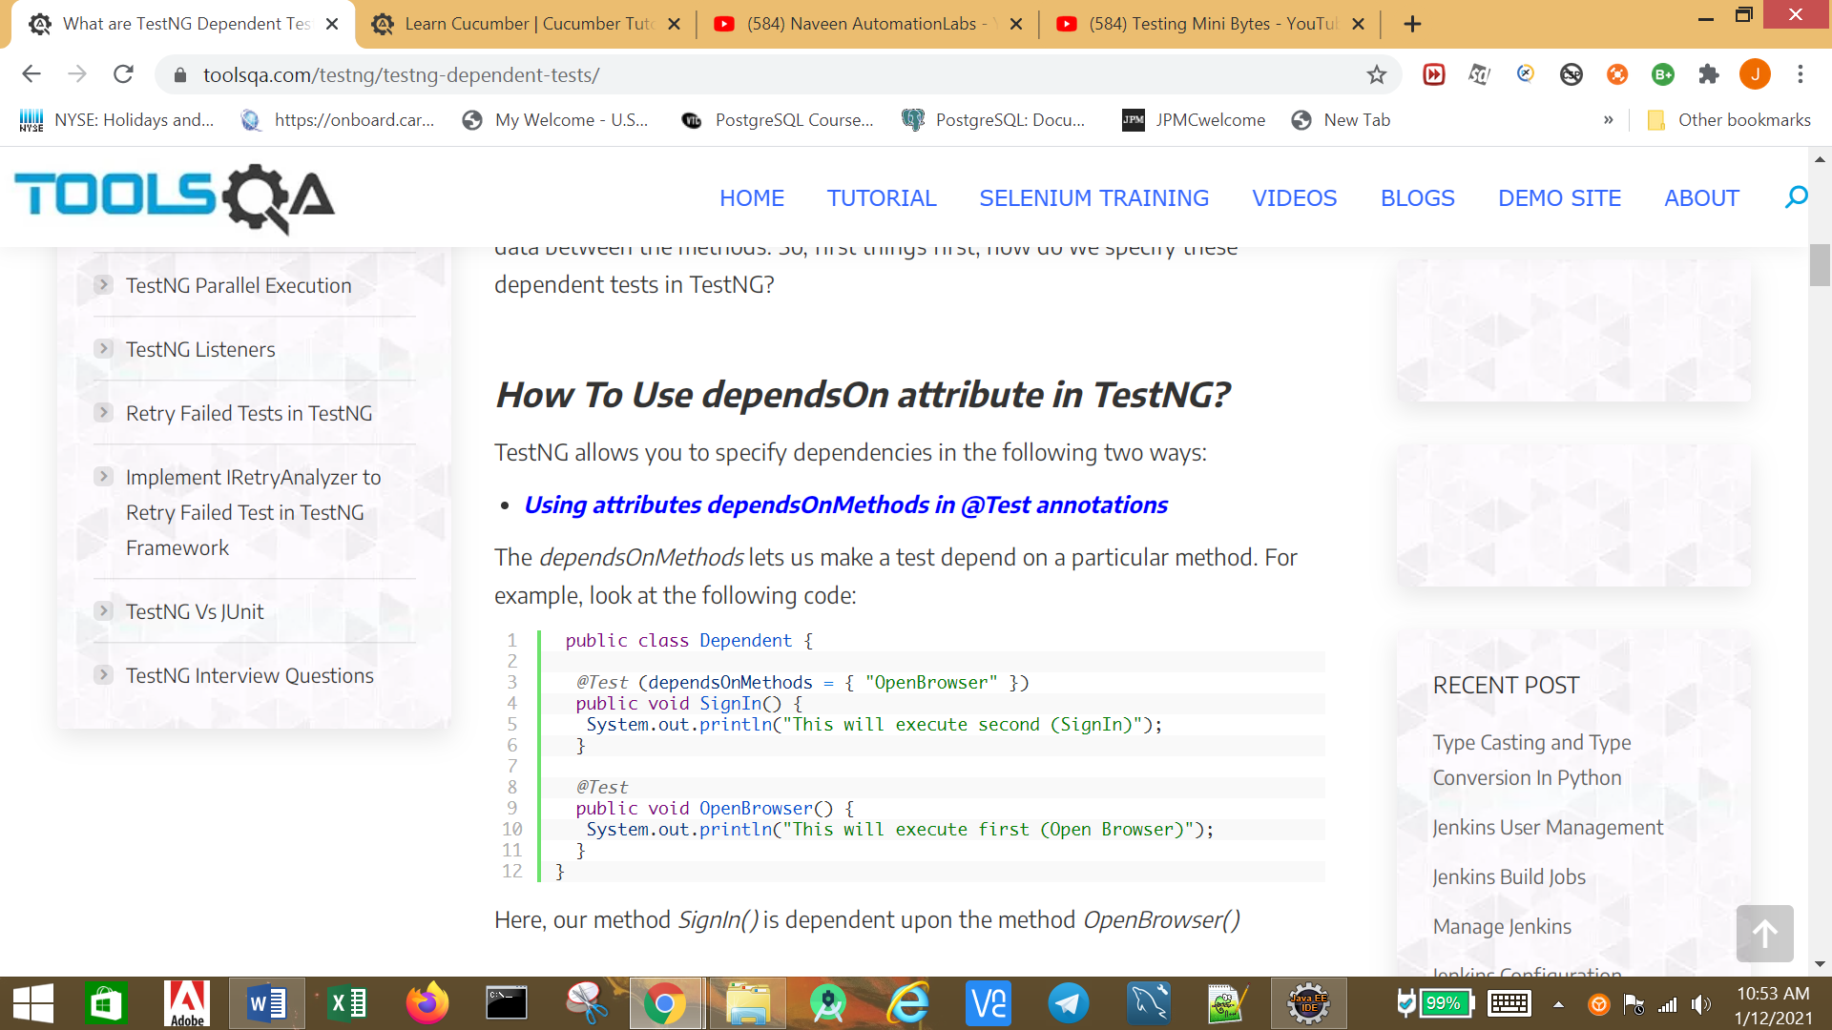

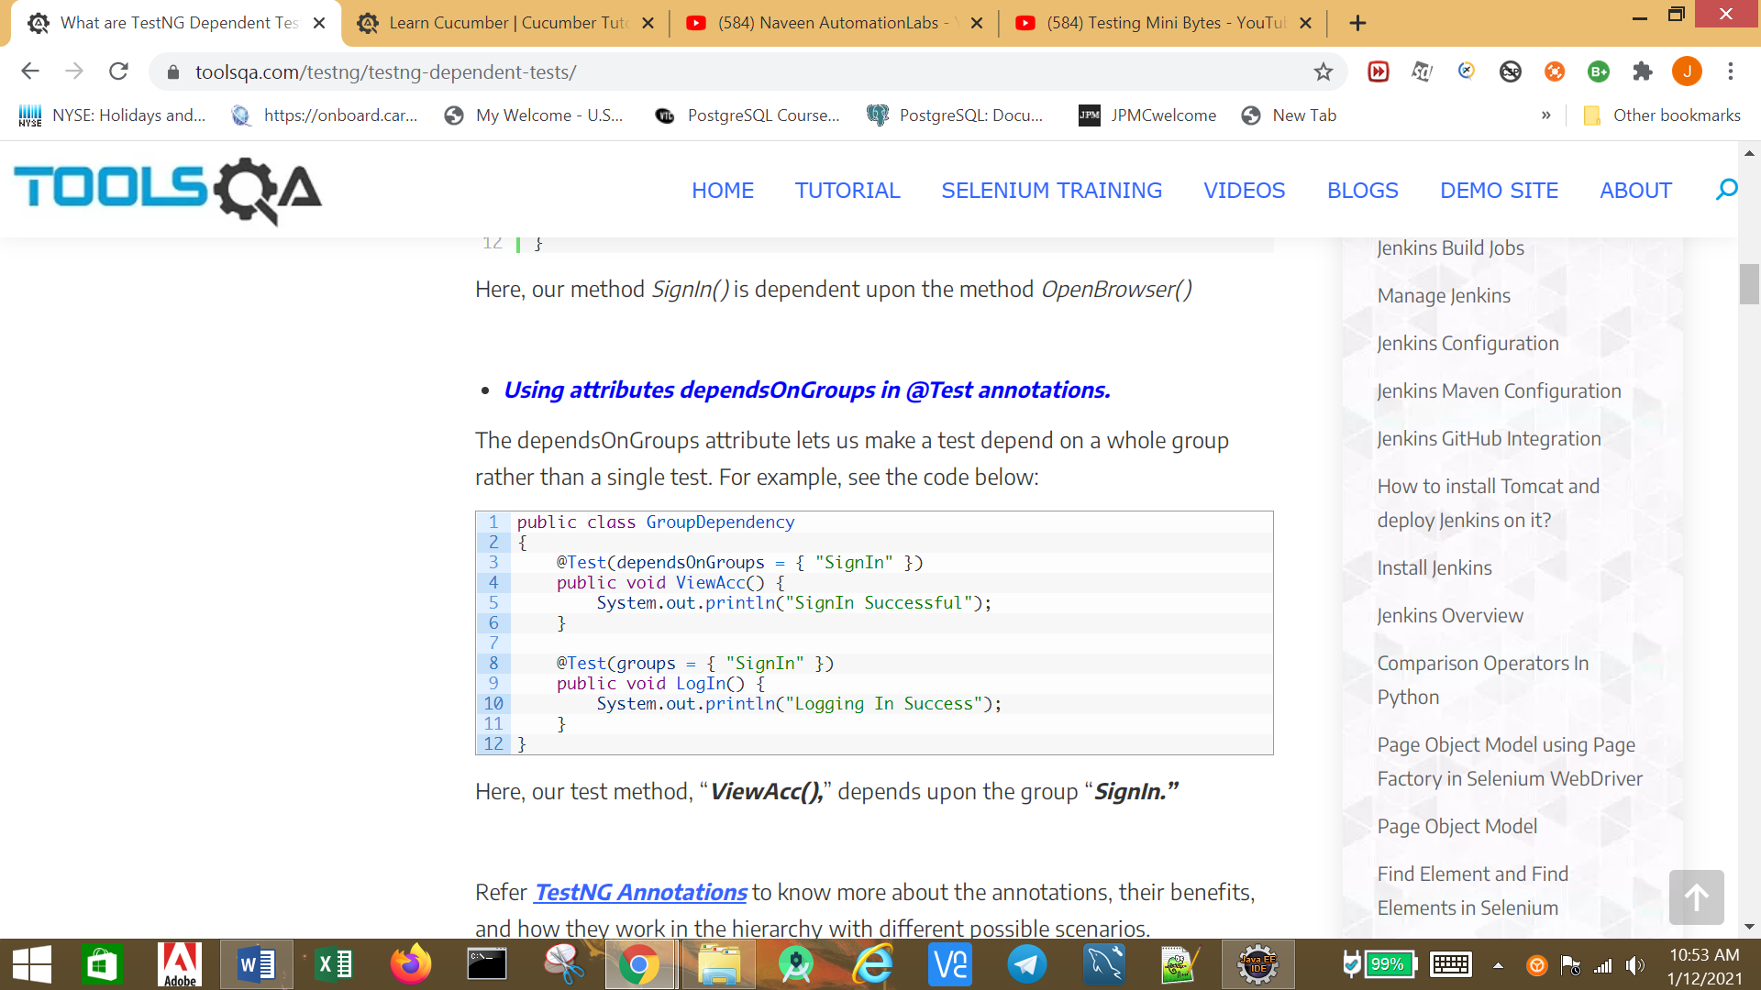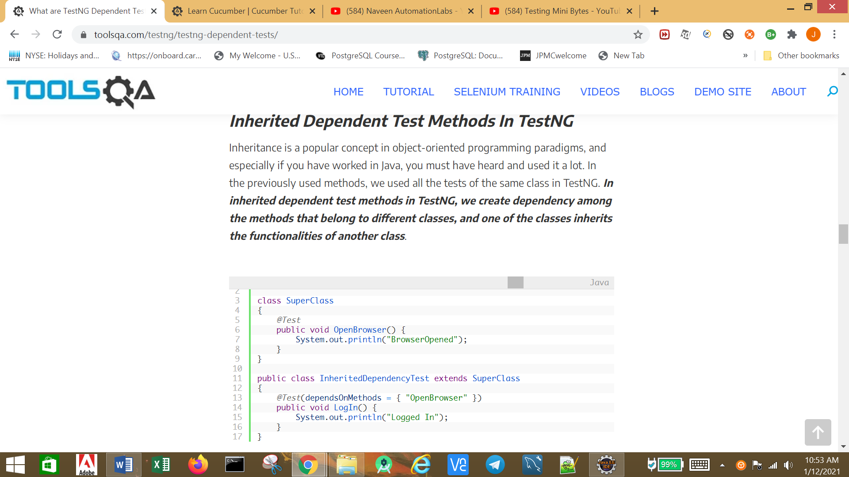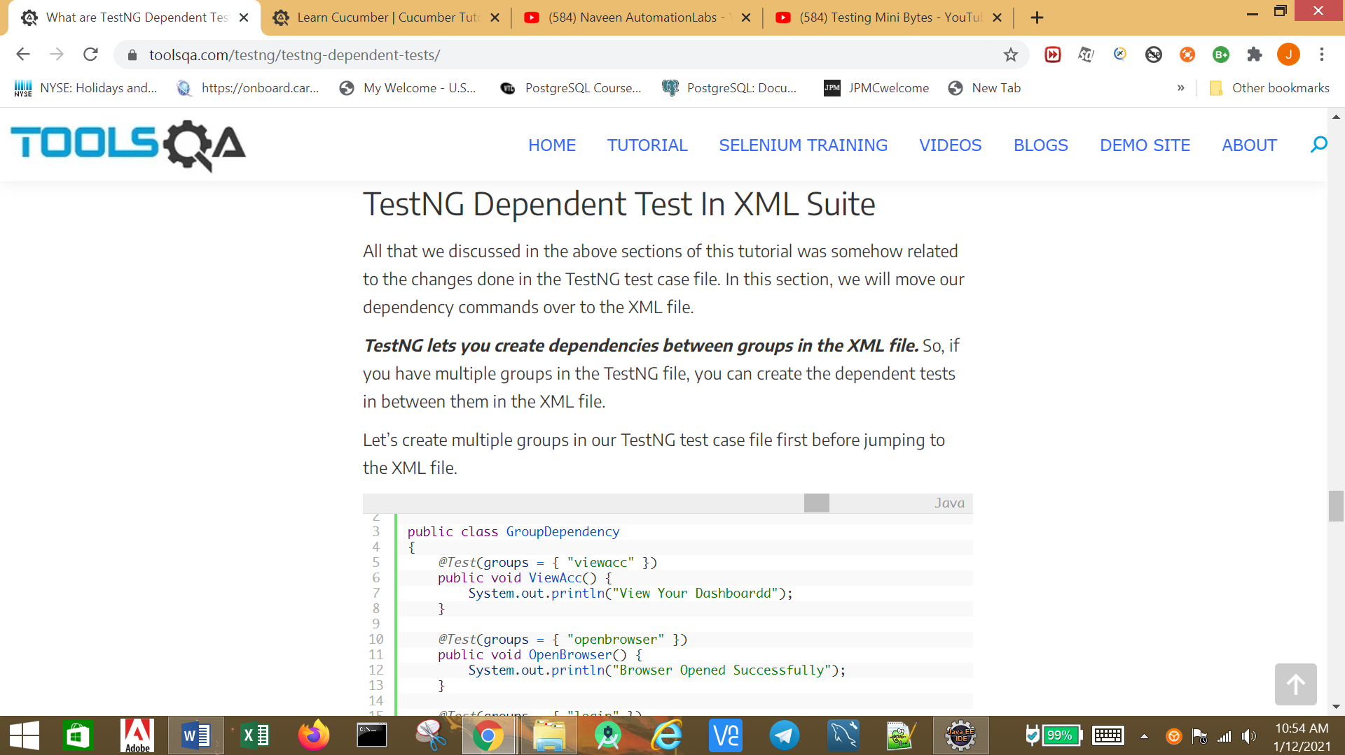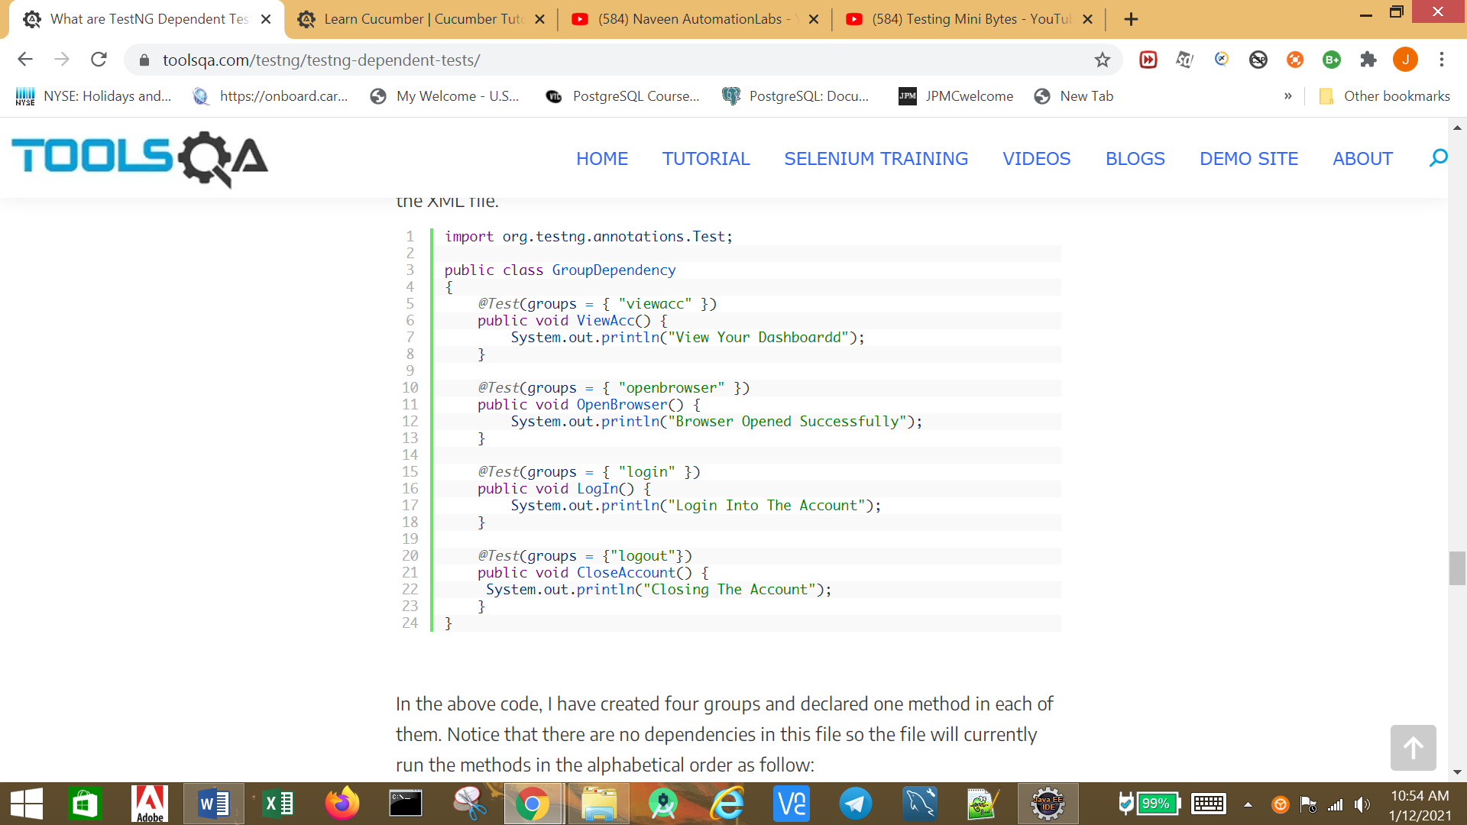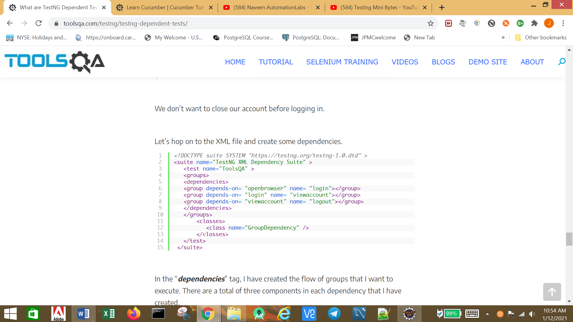

Parameters:

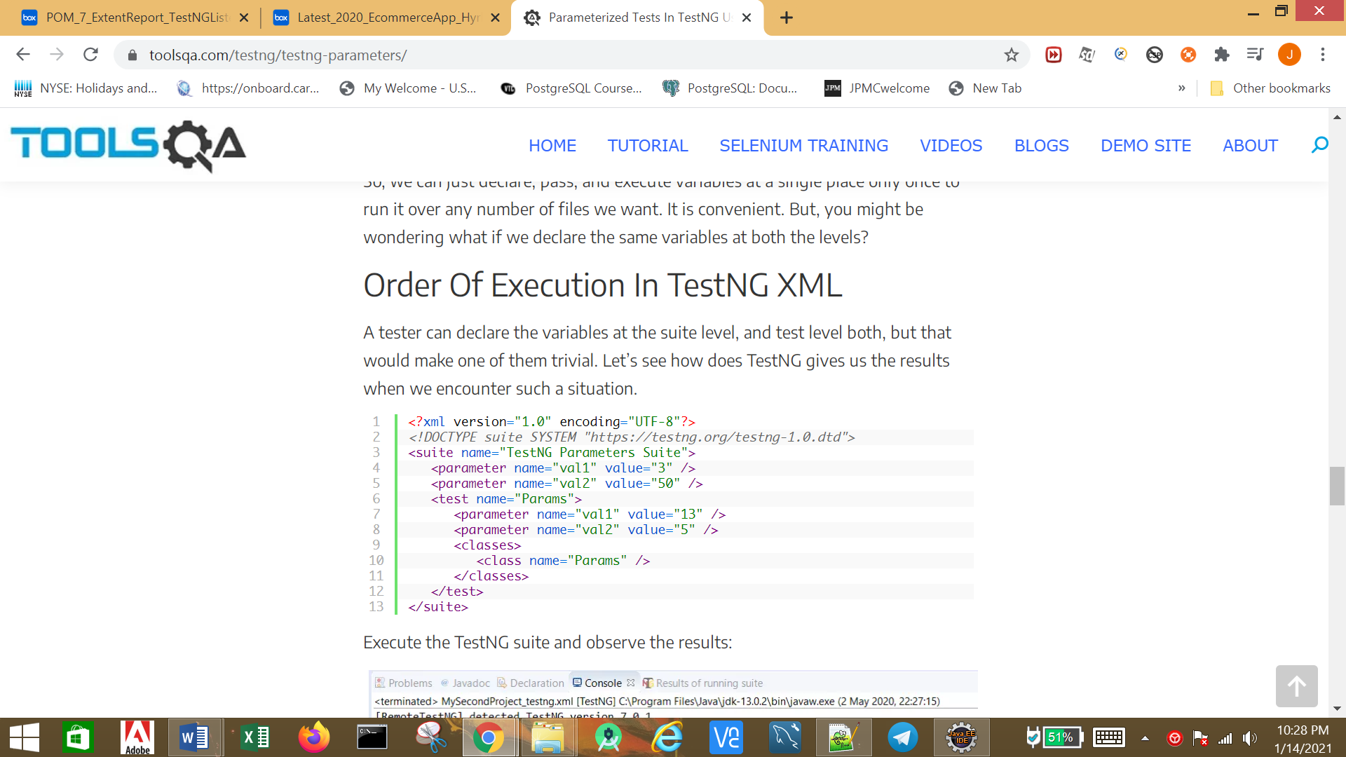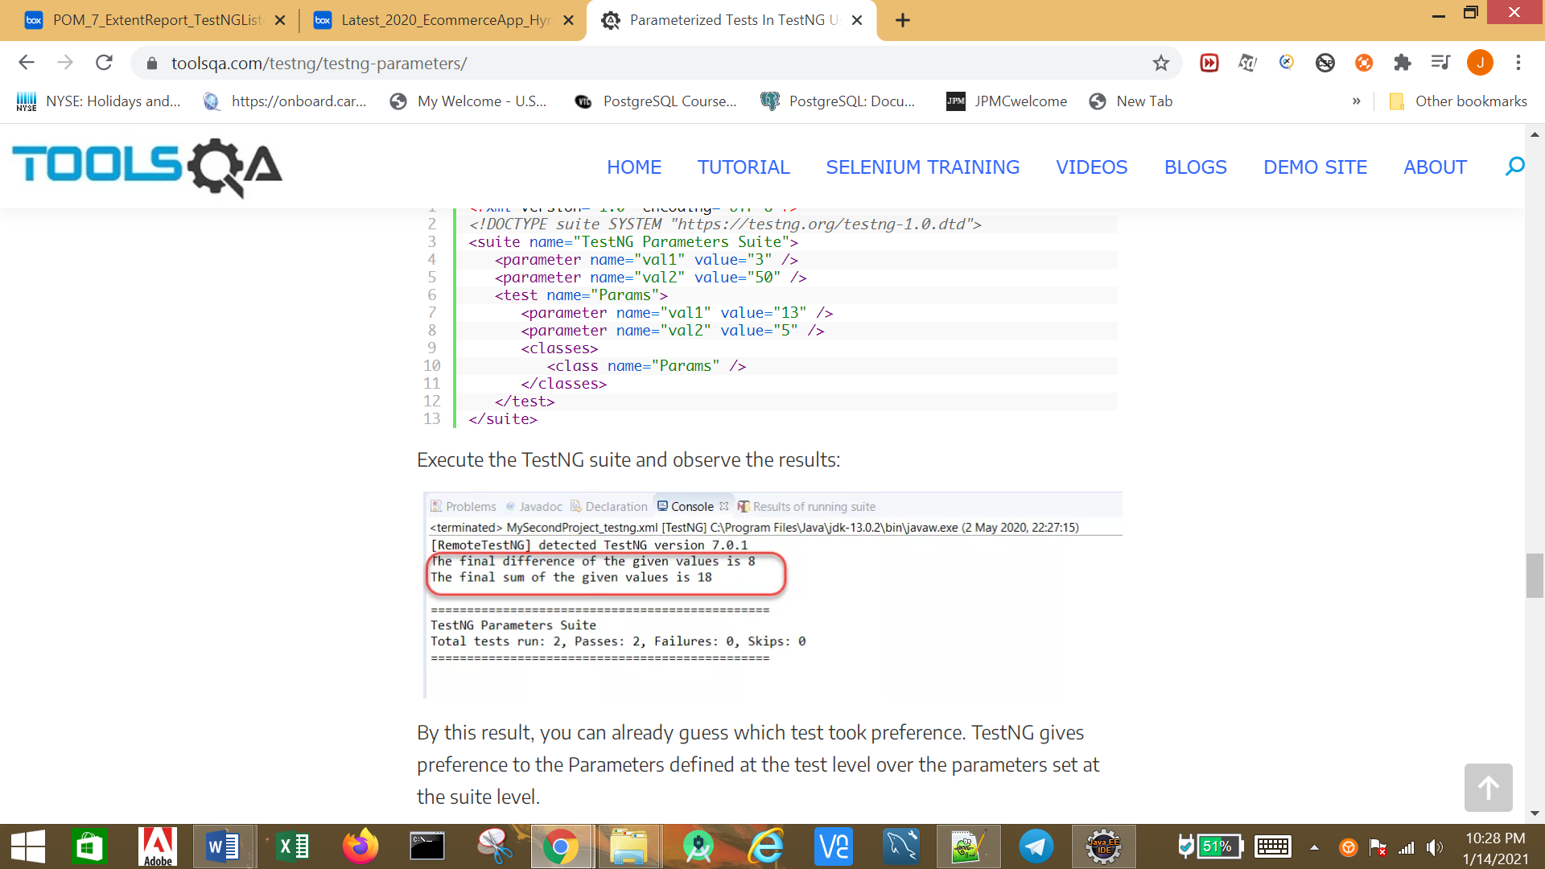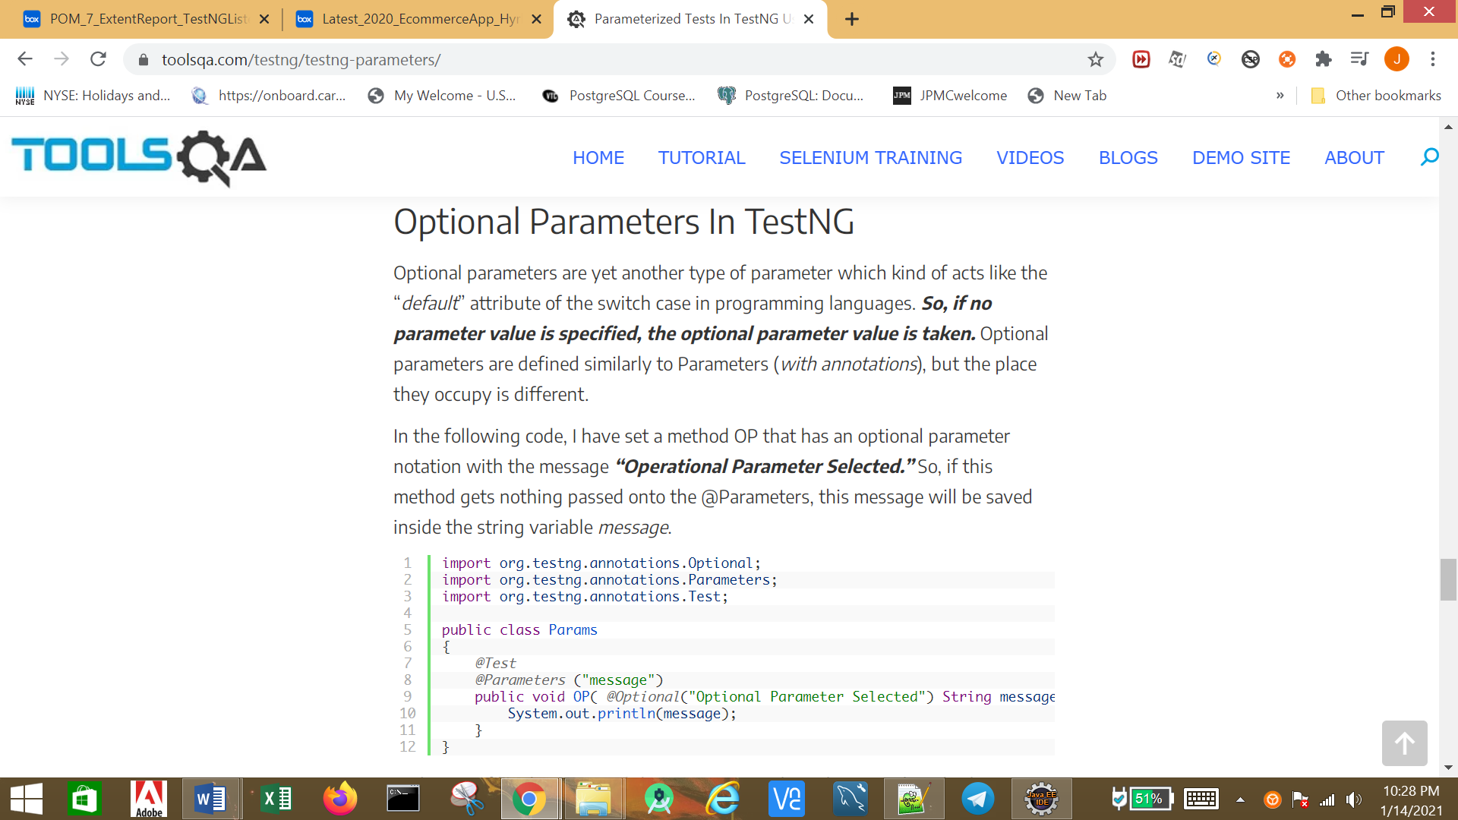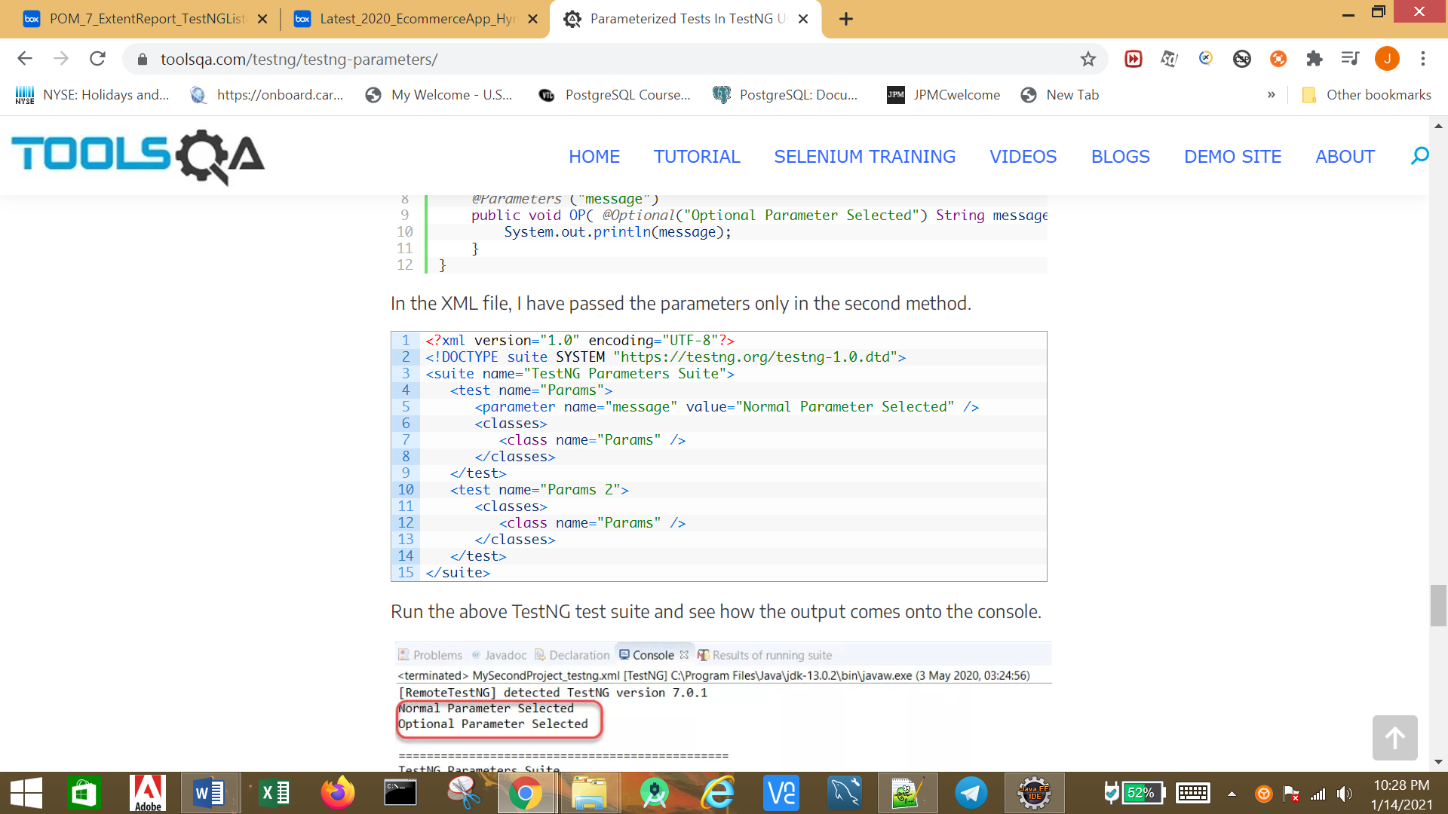

**Parallel Testing**

* ***Methods****: This will run the parallel tests on all @Test methods in TestNG.*
* ***Tests****: All the test cases present inside the <test> tag will run with this value.*
* ***Classes****: All the test cases present inside the classes that exist in the XML will run in parallel.*
* ***Instances****: This value will run all the test cases parallelly inside the same instance.*

### ***Running test methods parallelly in TestNG using Selenium***

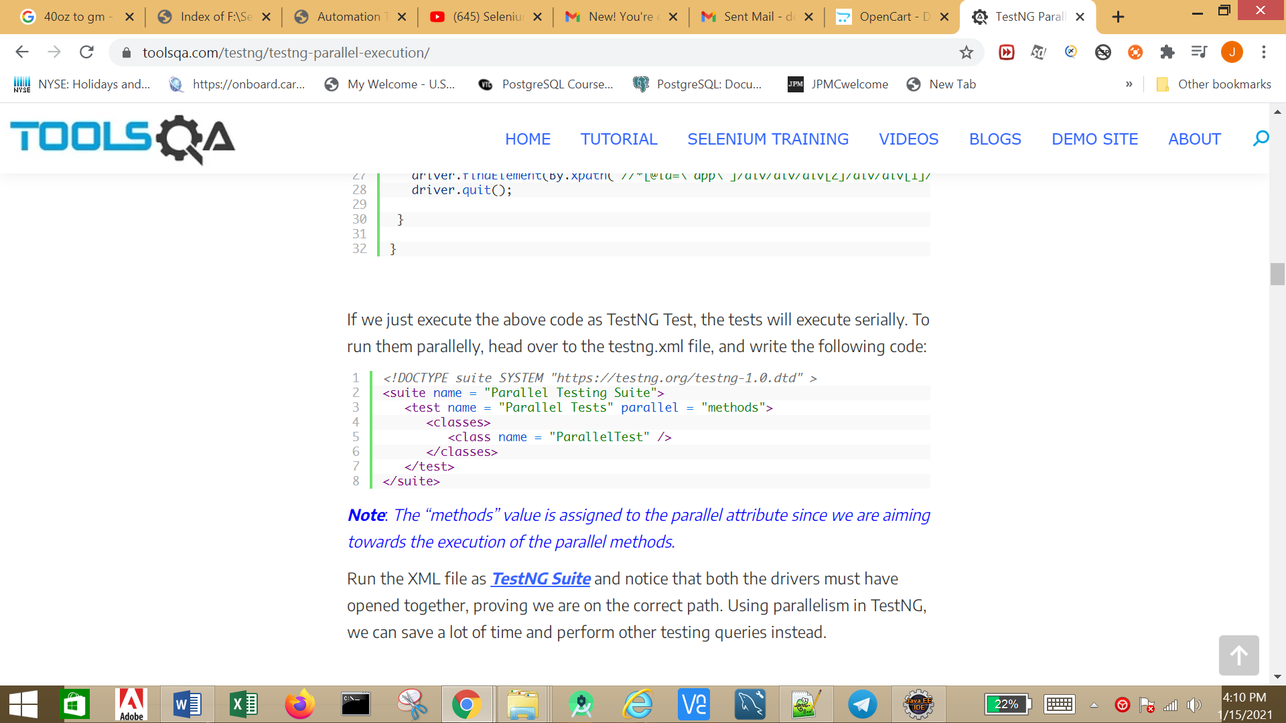

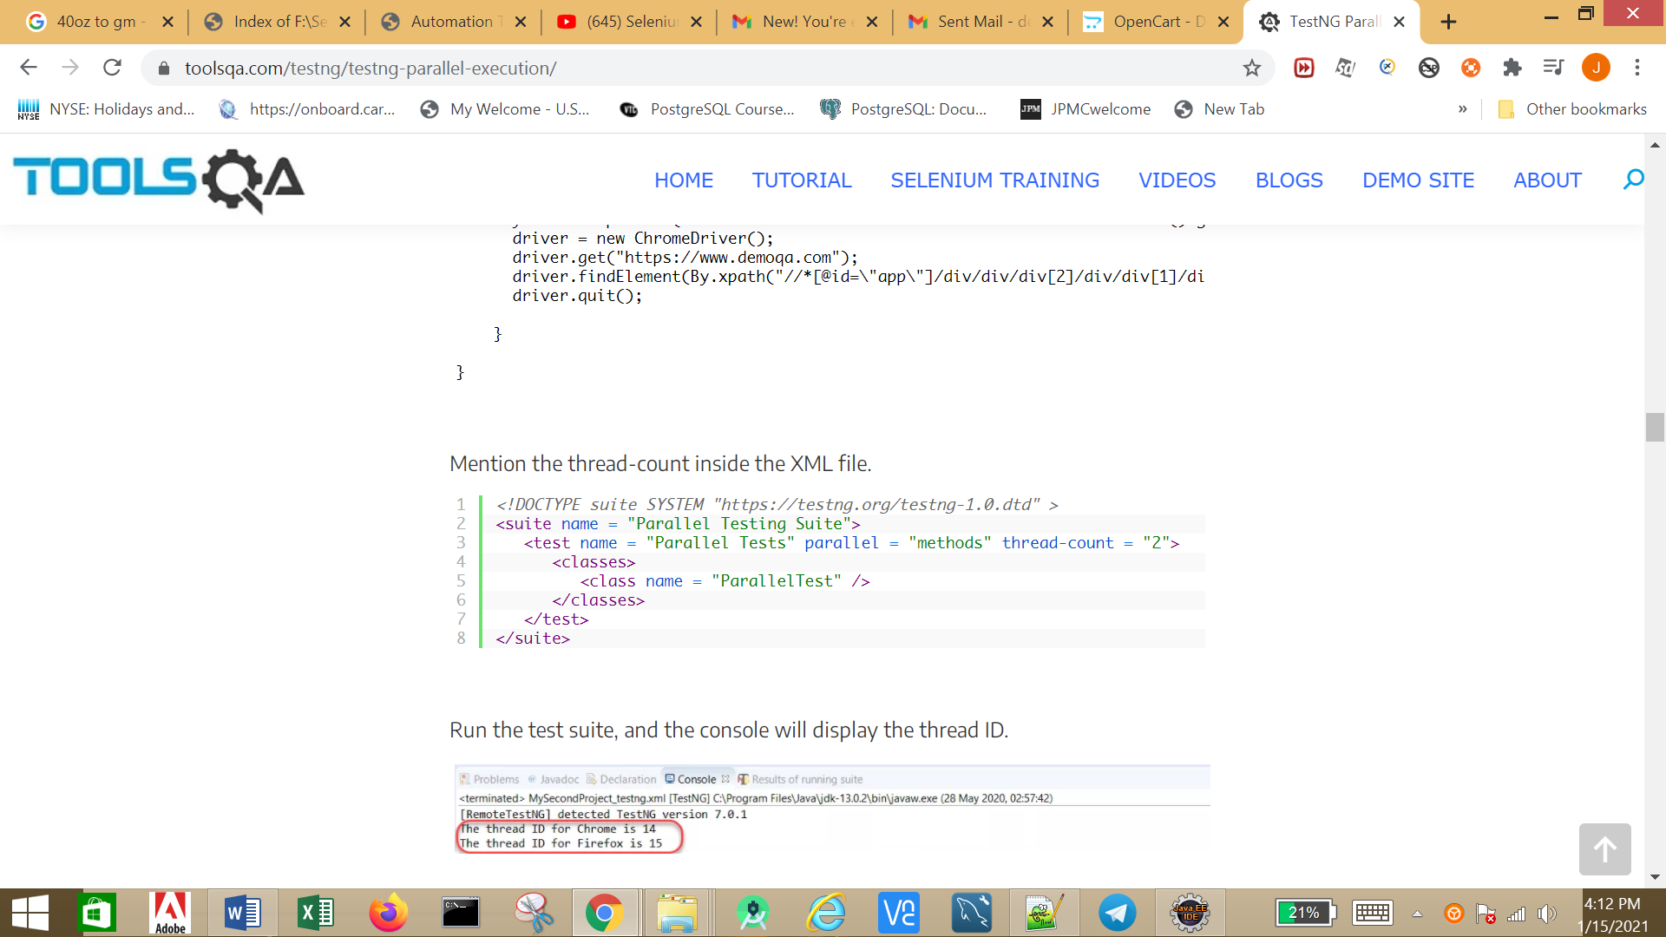

### ***Running test classes Parallelly in TestNG using Selenium***

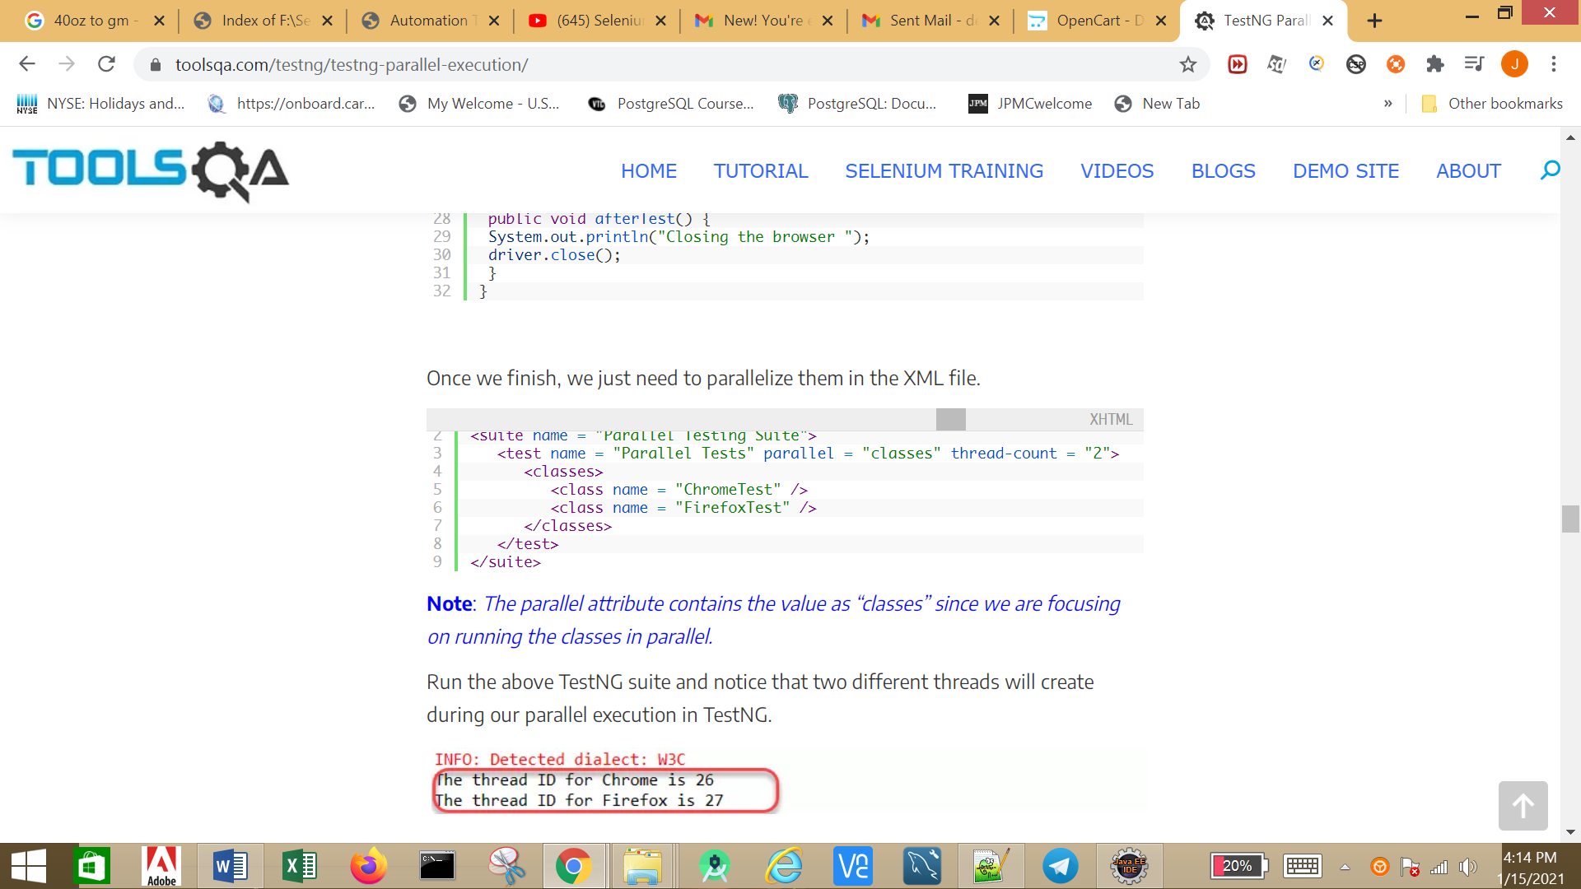

### ***Running Test Suites parallelly in TestNG using Selenium***

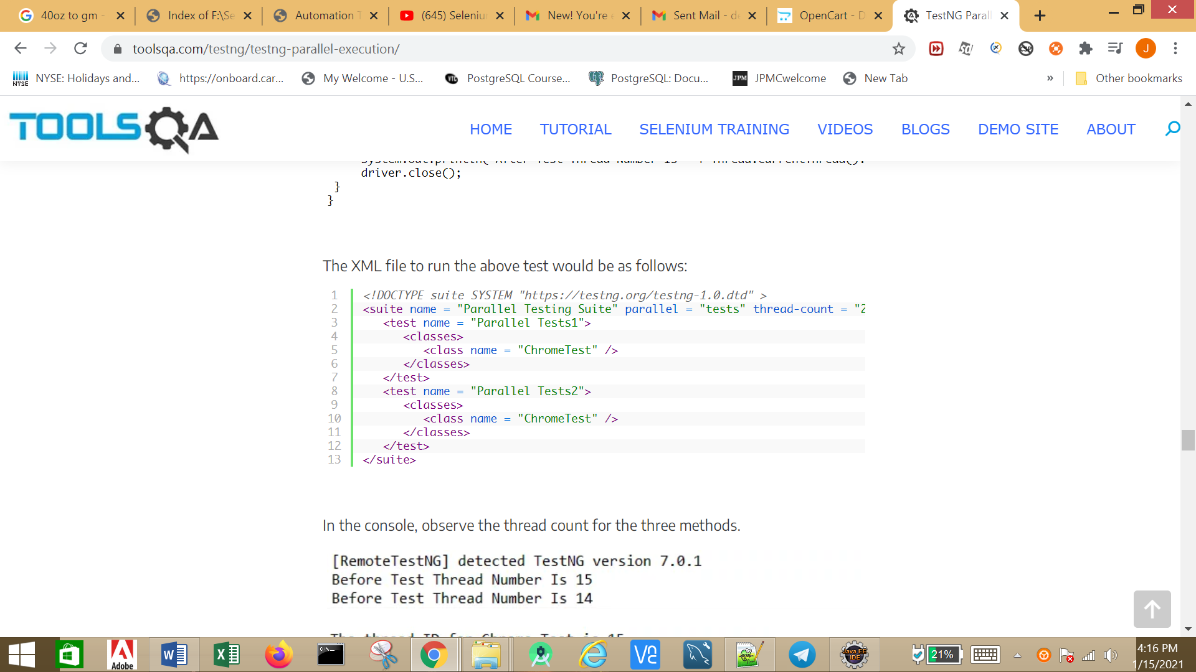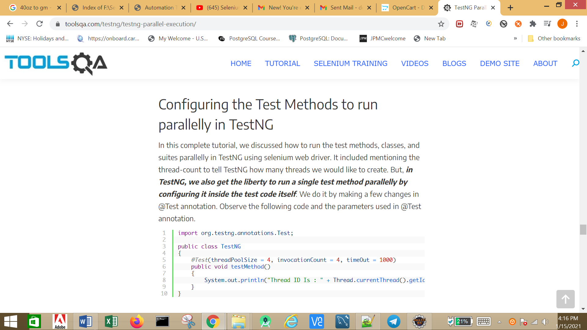In the @Test annotation, we need to mention three parameters:

* ***threadPoolSize****: The number of threads we would like to create and run the test parallelly.*
* ***invocationCount****: The number of times we would like to invoke this method.*
* ***timeOut****: The maximum time a test execution should take. If exceeded, the test fails automatically.*

## Parallel test execution using DataProviders in TestNG

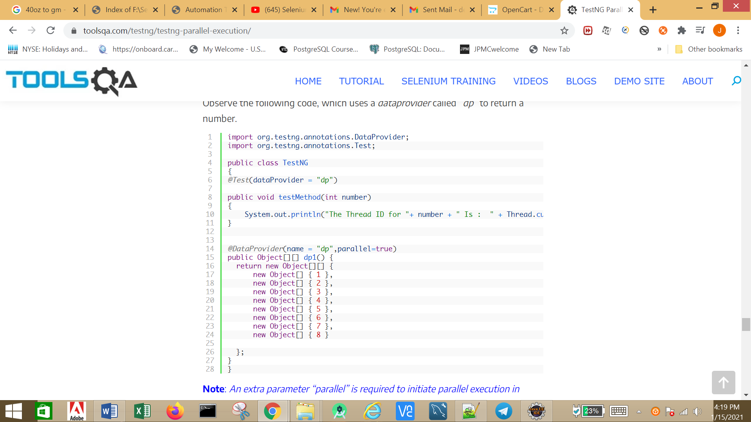

* **Note**: An extra parameter “parallel” is required to initiate parallel execution in TestNG using dataproviders.